Member VPN installation instructions
Contents
Member VPN installation instructions 1
For Windows users: (Windows 7/8/8.1/10/11) 1
For Apple MacOS users: (MacOS 12 or later) 4

For Windows users: (Windows 7/8/8.1/10/11)

Open link: https://www.wireguard.com/install/
Download the Windows installer on your computer and install it
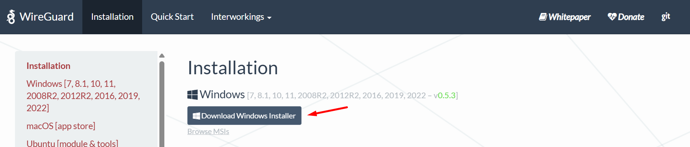

After installing, open the application, you should see this window:
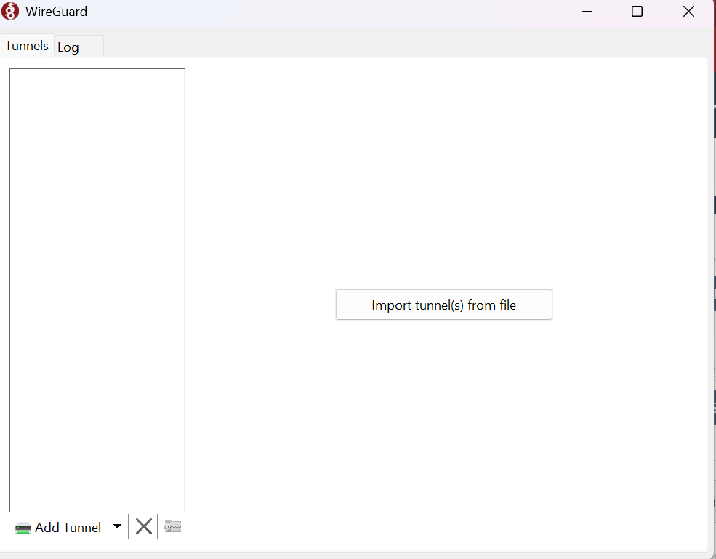
Click on “Add Tunnel”
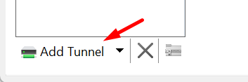
You will import the file that was sent you via email, it should be MemberVPN-[yourname].conf
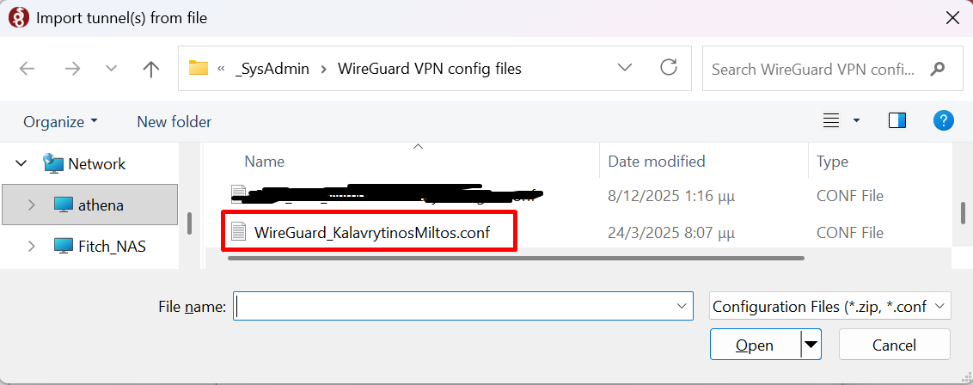
You click on “Open”
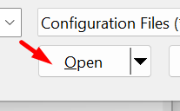
Now your window should look like this:
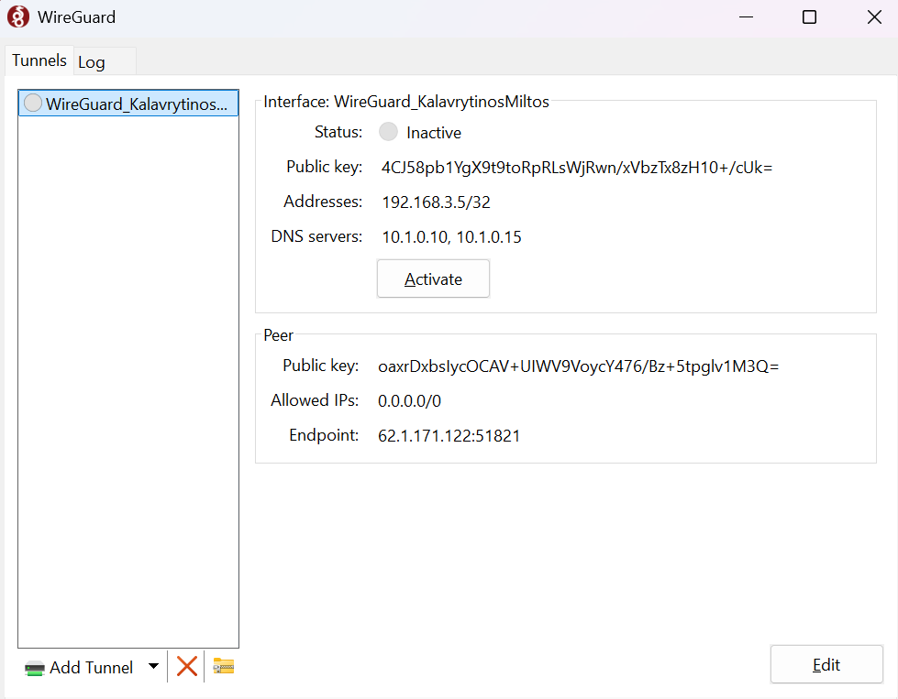

Click on “Activate”
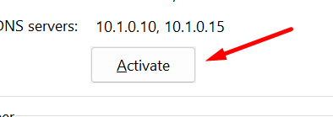
You should see something like this:
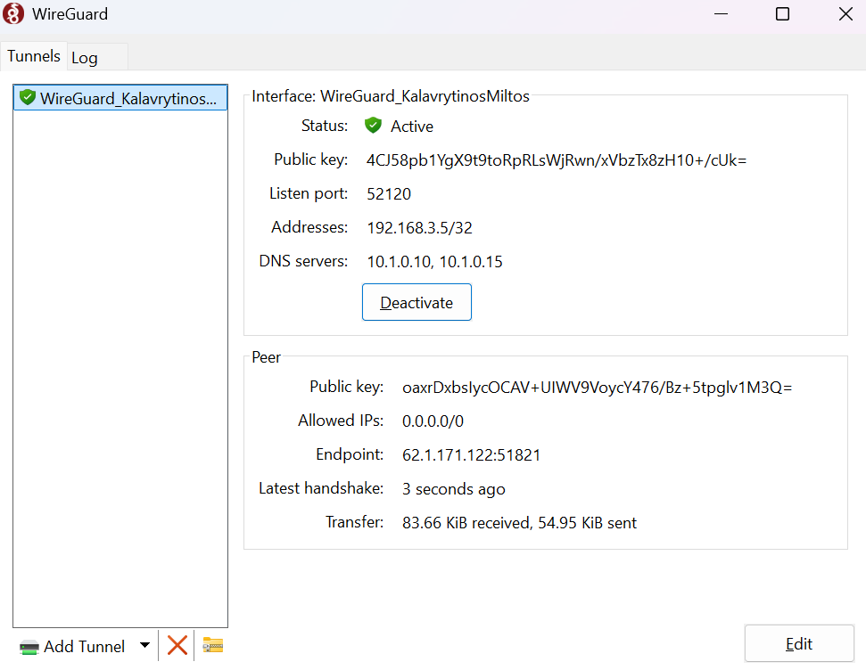
You are now part of the BSA’s Member VPN and have access to our Library resources.

For Apple MacOS users: (MacOS 12 or later)

Open link: https://www.wireguard.com/install/
Download the app from App Store: *you will need to have an Apple ID for this, if you do not have one, you will have to create one
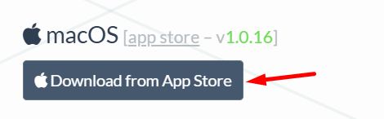
After installing the app from the App Store you will open it and see a window like this:
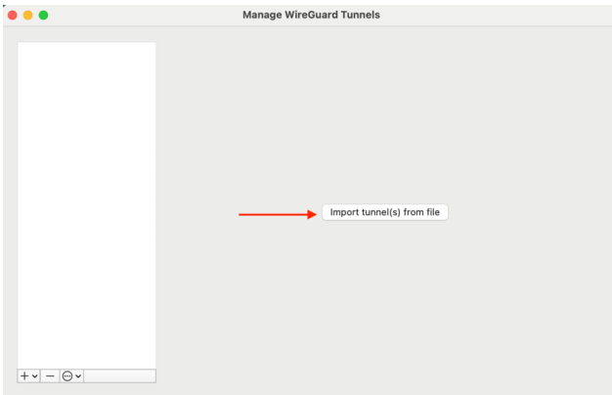
Click on ‘import tunnel’
You will import the file that was sent you via email, it should be MemberVPN-[yourname].conf


If you get a permissions dialog box, click Allow
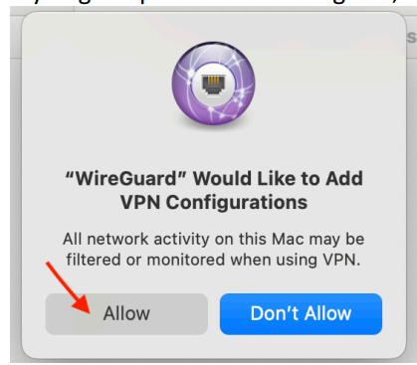
Depending on your MacOS version you might have to go to your Security settings and allow the app to run from there.

Once the VPN is installed, you can run it by clicking activate in the WireGuard client or locate it
in your normal Wifi >> VPN menu
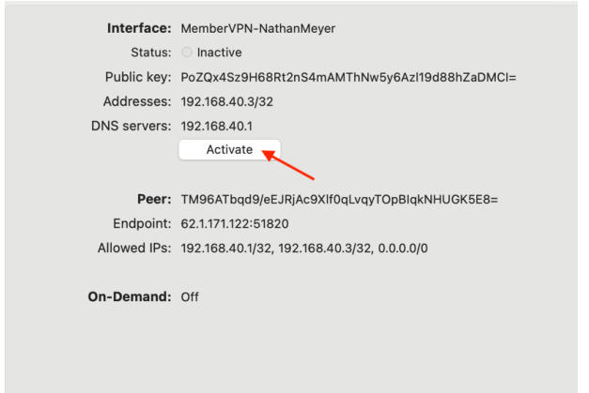
You are now part of the BSA’s Member VPN and have access to our Library resources.

